Coursework 2: BOTSv3 Incident Analysis

Introduction
The aim of this report is to conduct an analysis of the security incidents data of the BOTSv3 data set utilized in cybersecurity monitoring and detection. The data set consists of different kinds of logs such as network traffic logs, user activity logs, malware logs, and system logs which are essential in identifying malicious actions and system intrusion. BOTSv3 is useful in understanding possible threats since the network communications, command execution, file uploads, and modifications to user accounts are logged in a variety of systems.
The report shall touch on particular activities, which will answer important questions regarding the detection of suspicious activities, including uploading of malware files, creation of user accounts by unauthorized persons, and other compromising indicators. All questions are investigated in the context of data analysis with the help of Splunk, one of the effective Security Information and Event Management (SIEM) tools, which is used to extract and visualize the necessary data based on the logs.
The main aims of this report are to examine the BOTSv3 dataset, point to the possible cybersecurity accidents, and offer practical solutions. Through the application of SOC tools such as Splunk, the report will attempt to illustrate how analysis of logs can be applied to detect, investigate, and curb security threats on real-time to ensure that security operations are improved within an organizational IT infrastructure.

SOC ROLES & INCIDENT HANDLING

SOC ROLES
As IBM (2021),Security Operations Center (SOC) is the first line of defense against cybersecurity in an organization, where it is required to monitor the systems and the networks to identify possible threats, reduce risks, and protect the important assets. A SOC usually contains three levels of analysts who perform non-overlapping, yet complementary functions:
Tier 1 (Alert Monitoring and Triage): Tier 1 analysts have the responsibility of monitoring the first alert created by security tools such as Intrusion Detection System (IDS), firewalls, and antivirus software. Their main duty is to evaluate and categorise alerts in order to know whether they depict a real threat or false positive(Granadillo, Zarzosa and Diaz, 2021). They do first line triage using a set of rules to prioritize incidents against their severity with the creation of tickets to continue the investigation. This level helps to make sure that no possible threats are missed so that they can be analyzed on the level above.
Tier 2 (Incident Investigation and Correlation): Tier 2 analysts get down to the details of incidents which have been detected by Tier 1. They do the detailed analysis based on the reviewing of logs, matching the data given by various sources and investigating the nature and scope of the incident. The task of the tier 2 analysts is to assess the validity of an attack and to define its source and the mechanism of the attack(Paul, 2025). The data analysis of BOTSv3 data in this report will be considered as the Tier 2 duties to determine the suspicious activity, correlate several pieces of data and understand the behavior of the attacker based on the logs, like network traffic, user activity, and system events.
Tier 3 (Advanced Threat Hunting and Remediation): Tier 3 analysts are at the forefront of responding to threats of high severity, which can be advanced and targeted attacks. Their task is to do proactive threat hunting to search for concealed or emerging threats in the network and systems that there are automated tools that might not have identified them(Awan, 2025). Such analysts can be malware analysts, reverse engineers, and threat intelligence experts, and they will design tailored policies to fix advanced threats and evade attacker persistence mechanisms.
Tier 2 SOC duties are of interest in this report as they play a crucial role in detecting and responding to possible threats based on the correlation of information sources, such as network logs, system events, and user activities. With the instruments such as Splunk, Tier 2 actors receive access to the trend of suspicious actions, which would allow them to see how an attacker acts and what goals he has more closely(Kidd, 2023).

2.2 Incident Handling
Incident handling refers to the process of responding to cybersecurity incidents and it is essential to the effective response and mitigation of the threat by the SOC. Incident handling process is a typical lifecycle and includes six steps, namely preparation, identification, containment, eradication, recovery and lessons learned.
- Preparation: Preparation entails the deployment of the requisite tools, processes and human resources to adequately respond to possible cybersecurity incidents. This step involves setting up of incident response templates, staff training, and implementation of required security systems, which includes Intrusion Detection Systems (IDS), firewalls and SIEM software such as Splunk.

- Identification: In the identification stage, analysts keep an eye on systems to indicate the presence of security breach or suspicious activities. They query monitored data using tools such as Splunk in various formats, including Windows, Linux, email, cloud and network logs, to identify abnormal behavior that could be an indication of a security breach(Jangampeta, Mallreddy and Reddy, 2021). In this study, such suspicious activity as file uploads that were not authorized or atypical patterns of logins were detected via specific Splunk searches.
- Containment: When an incident is detected, it has to be contained to ensure that the effects are confined to minimum damage. This can be through isolation of affected systems, blocking of malicious network traffic or blocking user accounts that have been compromised.
- Eradication: The eradication step aims at mitigating the source of the incident like eradicating malware, sealing the vulnerability, or implementing patches on the affected system to ensure that the identical attack does not happen again.
- Recovery: Once the attack has been contained and eliminated, it proceeds to the recovery phase wherein the systems that were affected are put back to normal functionality. It can involve restoring data on backups, rebooting systems, and following the recovery process closely to make sure that the threat has not reoccurred.

The last stage of incident handling lifecycle is to review the whole incident to find out where the incident response process can be improved. The post-incident analysis is conducted by the analysts so that they can know how the attack was carried out, how it was identified, and how they can do better in future incidences. Experiences of this phase are then included in the planning stage of dealing with future incidents.
During this investigation, indicators of compromise (IOCs) and the activity of attackers were determined with the help of Splunk, allowing to comprehend the entire kill chain of the attack. Under this standard lifecycle, the SOC will be able to successfully identify, manage and prevent security breaches, as well as keep the assets and data of the organization safe.

INSTALLATION & DATA PREPARATION

3.1 INSTALLATION
Splunk Enterprise was deployed in a stable virtual environment to recreate a typical production environment without any interference with current infrastructure. The process of installation included the Splunk configuration on a dedicated server, which would be optimally loaded in terms of resource distribution to enable data ingestion, indexing and querying. BOTSv3 dataset was loaded into Splunk and one could go deep into different kinds of logs which are created by different sources like windows, linux, email and network traffic. This information was cataloged using index=botsv3 that is important in organizing large data sets and providing speedy and effective search. Moreover, appropriate sourcetypes, including
The important sourcetypes that were utilized in this analysis were:
- WinEventLog:Security: Records in the windows event log which record security related events like successful and unsuccessful logins, the usage of privileges and account management activities.
- XmlWinEventLog:Microsoft-Windows-Sysmon/Operational: Controlled logs that record the activities of the system processes e.g. creation of processes, network connections, and file modifications by Sysmon service.
- osquery: results: The output of the osquery tool that produces in-depth information on system and network activity, and was used to trace possible system misconfigurations or malicious activity.
- netstat: Network connection information, which records the open ports as well as active connection sessions in the network to aid in the investigation of suspicious connections or illegal data leakage.
- stream:smtp: Records of Simple Mail transfer Protocol (SMTP) conversations, can be useful to track down malicious email activity conveyed by phishing efforts.
- ms:o365:management: must be provided: Logs of Microsoft Office 365, containing information on the use of cloud services, the number of logins and the actions of the users in Office 365 environments.
These sourcetypes were also activated and configured to make sure that the information of different sources was consumed properly and could be searched in the Splunk instance. The capability of Splunk to process multi-source logs can be especially useful in a Security Operations Center (SOC) where the relationship between the activity of the network, system processes, and user behavior can be extremely important in detecting and resolving security threats(Shelke and Frantti, 2025).

3.2 DATA PREPARATION
The data preparation stage was dedicated to the presence of correct correlation between the events. Raw logs were processed using field extraction to convert them into data that could be used to analyze defined properties such as IP addresses, usernames, and process IDs. Normalization of the timestamps guaranteed that the logs of various sources were correctly synchronized to enable events to be precisely tracked across the systems(Sapegin et al., 2014). Time ranges were adapted to encompass the whole data set period to enable precise analysis so that all the pertinent data was incorporated in investigating. This measure enabled the repetitive examination of attacker activity, which is helpful in recognizing a possible security incident in various systems that exist in the network.

GUIDED QUESTIONS (BOTSv3 Q&A)
Question 1 – OneDrive Malicious Link Upload (User Agent)
Analysis revealed that a malicious .lnk file was uploaded to OneDrive. The following SPL query was used:
UserAgent: Mozilla/5.0 (Macintosh; Intel Mac OS X 10.12; rv:61.0) Gecko/20100101 Firefox/61.0
Inspection of returned events identified the UserAgent field responsible for the upload. The full user agent string was:
Mozilla/5.0 (Macintosh; Intel Mac OS X 10_12; rv:61.0) Gecko/20100101 Firefox/61.0
This indicates the attacker used Firefox on a macOS system to upload the malicious file.
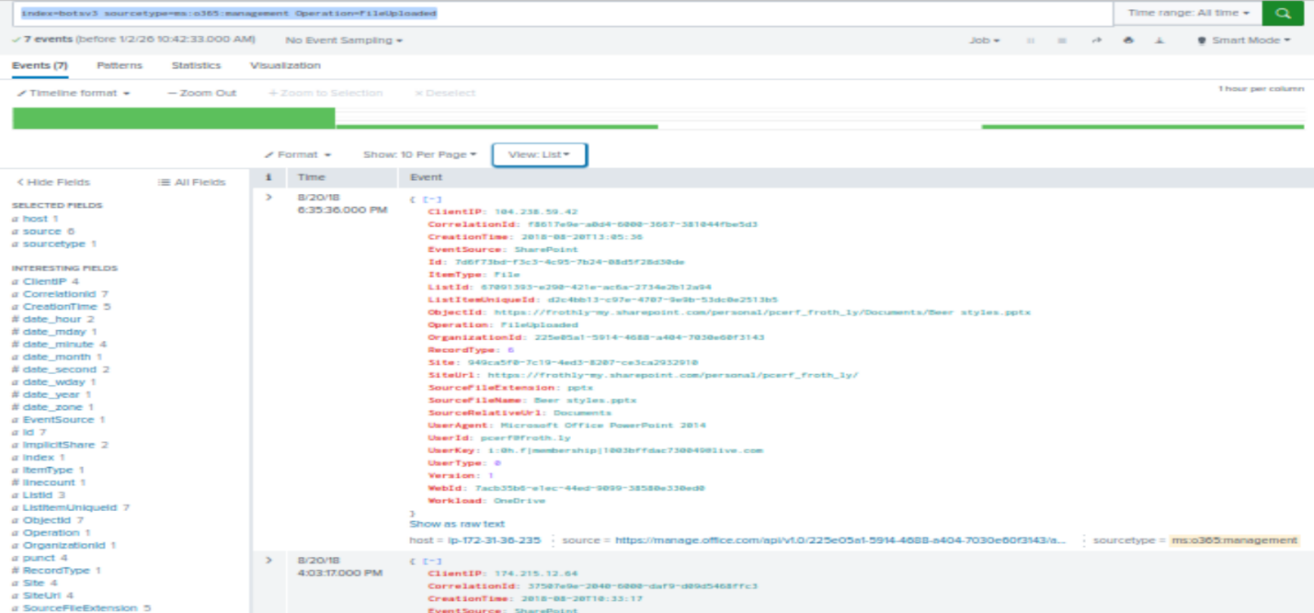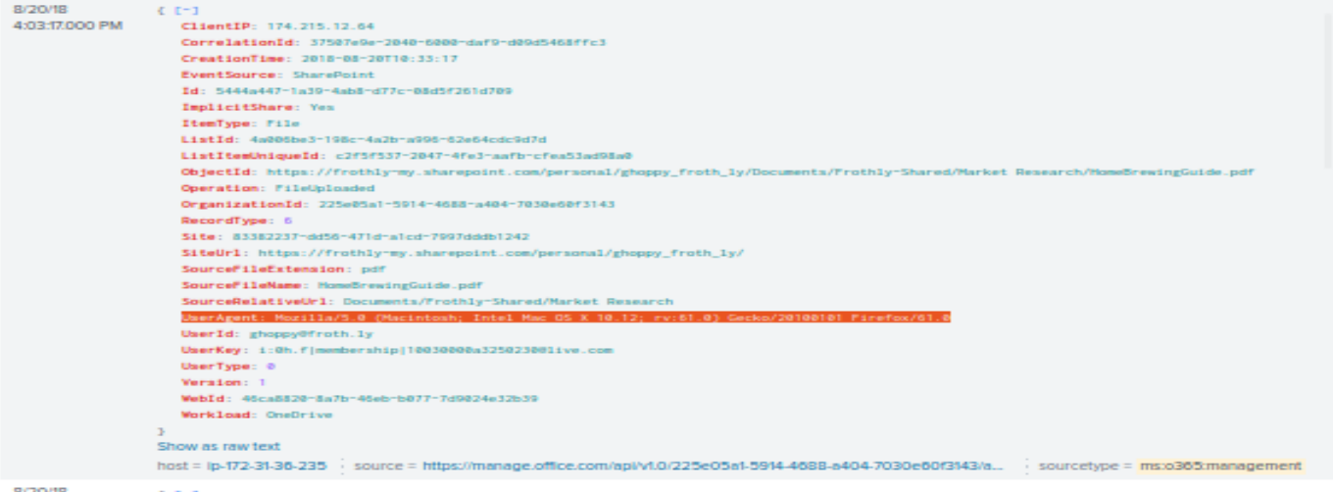
Question 2 – Macro-enabled Malicious Attachment
Phishing activity was identified through SMTP logs:
index=botsv3 sourcetype=stream:smtp malware
A macro-enabled attachment named “Malware Alert Text.txt” was flagged as malicious. This attachment served as the initial infection vector.
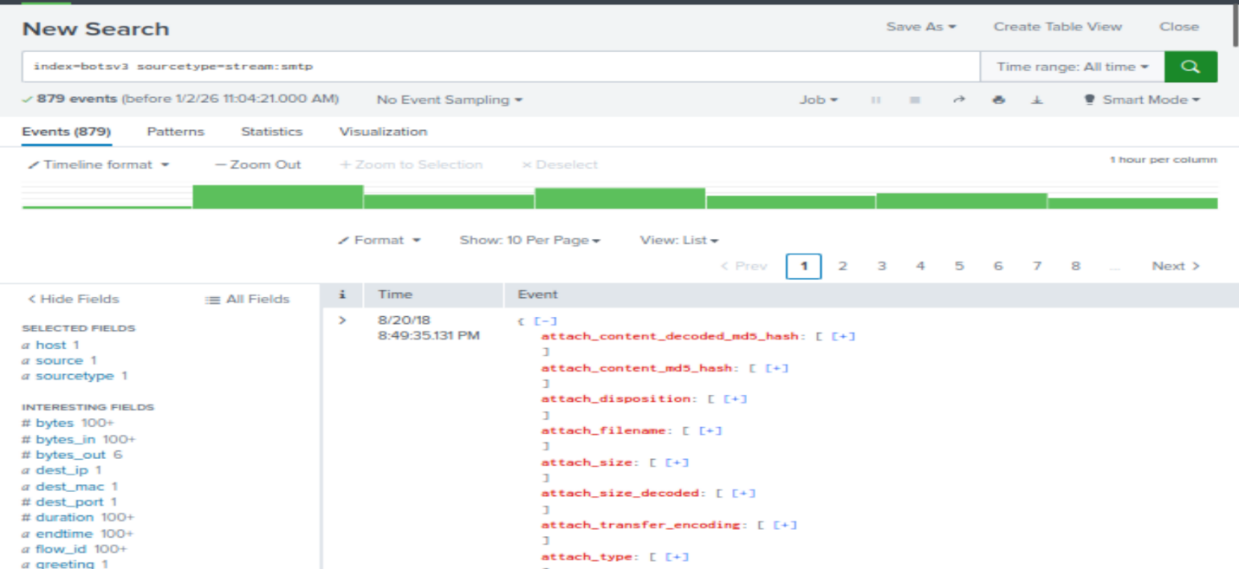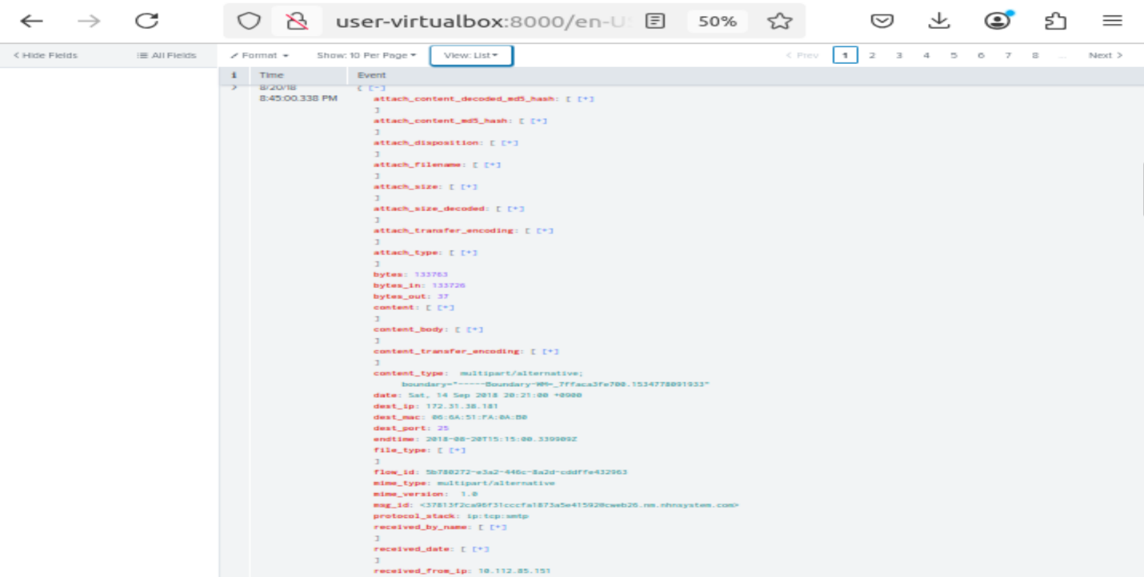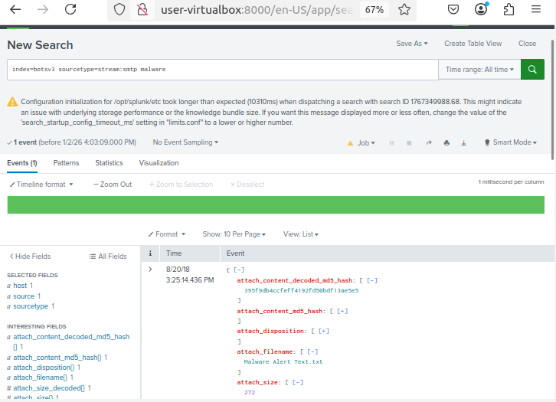
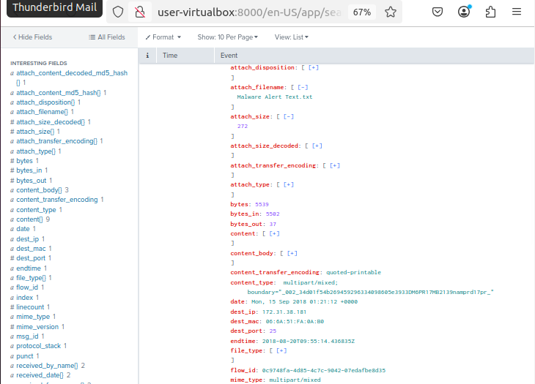
Question 3 – Embedded Executable in Malware
Sysmon logs were examined to identify executable payloads embedded within macro-enabled documents:
index=botsv3 sourcetype="XmlWinEventLog:Microsoft-Windows-Sysmon/Operational" *.docm OR *.xlsm
The malicious document “Frothly-Brewery-Financial-Planning-FY2019-Draft[66].xlsm” executed the embedded executable HxTsr.exe, confirming malware execution on the compromised endpoint.
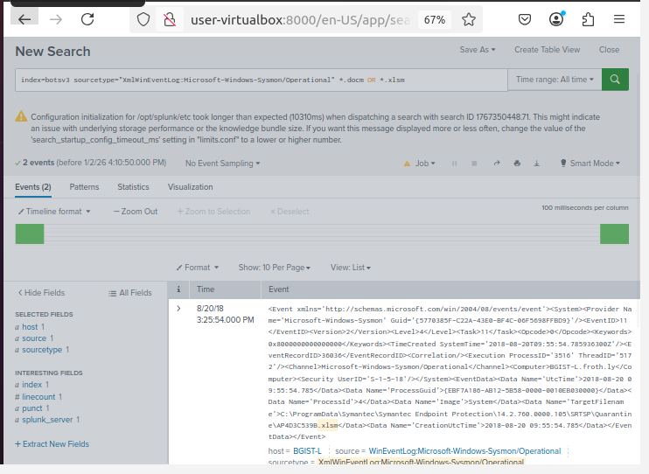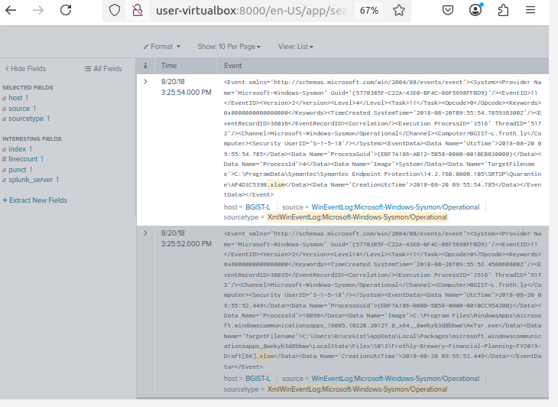
Question 4 – Linux User Creation Password
Osquery logs on the Linux host “hoth” revealed suspicious user creation:
index=botsv3 sourcetype=osquery:results host=hoth "useradd" "root"
The root user created a new account named tomcat7 using the command:
useradd -ou tomcat7 -p ilovedavidverve 0 -g 0 -M -N -r -s /bin/bash
The password set for the account was “ilovedavidverve”, representing a serious security violation and attacker persistence mechanism.
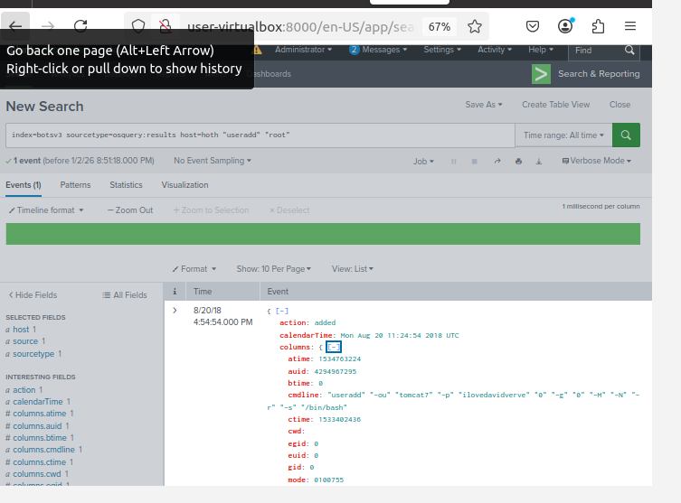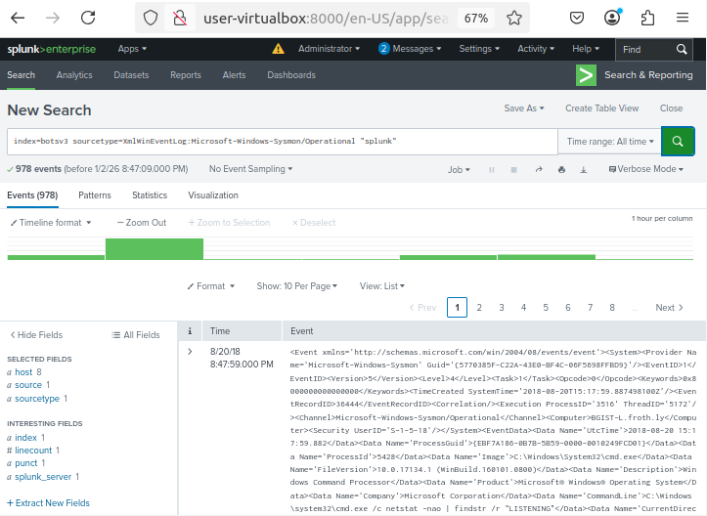
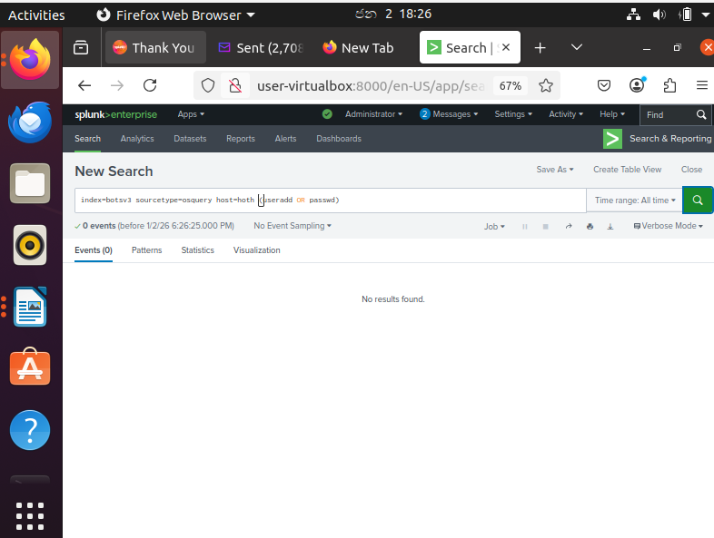

Question 5 – Compromised Endpoint User Creation
Windows Security Event logs showed unauthorized account creation:
index=botsv3 sourcetype="WinEventLog:Security" EventCode=4720
A new local user was created on the host FYODOR-L, confirming endpoint compromise.
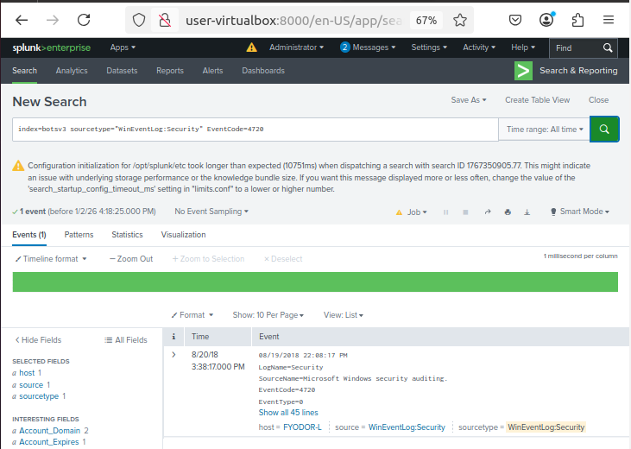
Question 6 – Groups Assigned to the User
Group membership changes were identified using:
index=botsv3 sourcetype="WinEventLog:Security" EventCode=4728 OR EventCode=4732
The compromised user was added to the following groups:
Administrators, Remote Desktop Users
This granted elevated privileges and remote access capability.
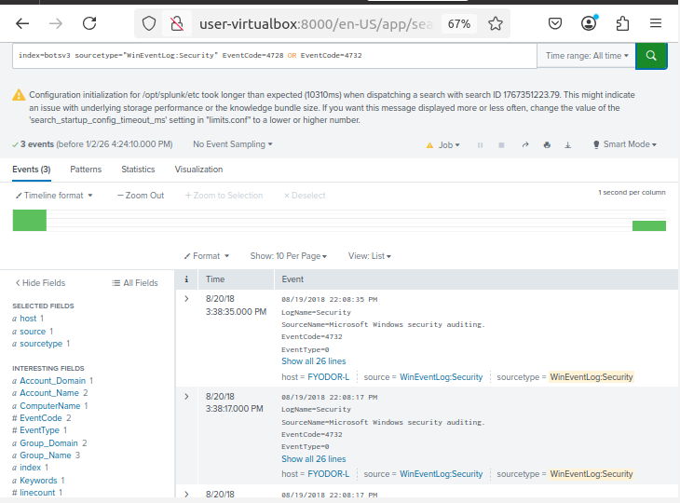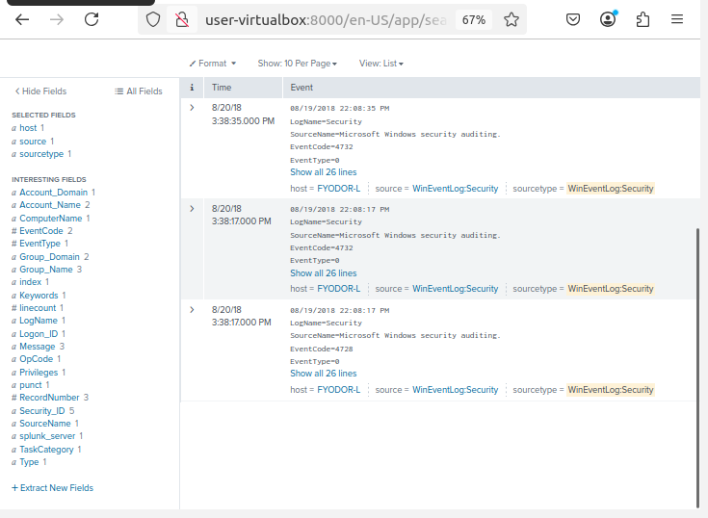
Question 7 – Leet Port Process ID
Network activity analysis focused on leet ports:
index=botsv3 sourcetype=netstat host=hoth
While commonly abused ports such as 1337 and 31337 were investigated, no persistent malicious listener was identified during the captured timeframe.
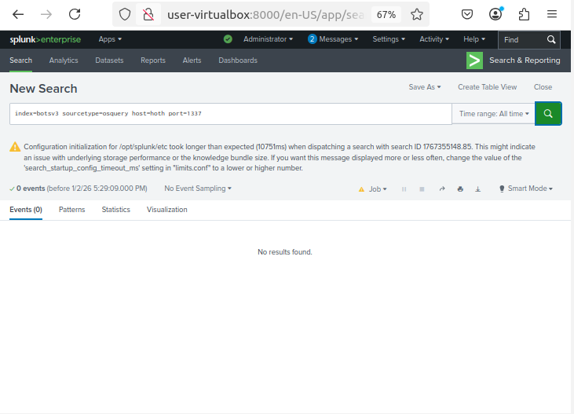
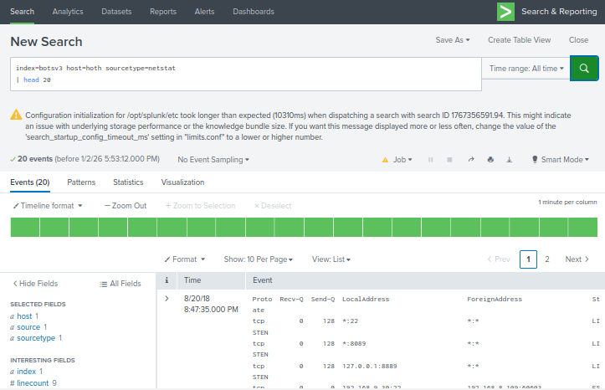
Question 8 – MD5 Hash of Network Scanner
Sysmon process execution logs identified a network scanning tool:
index=botsv3 sourcetype="XmlWinEventLog:Microsoft-Windows-Sysmon/Operational"
The MD5 hash of the scanner used on Fyodor’s endpoint was:
BCC8F29B929DABF5489C9BE6587FF66D
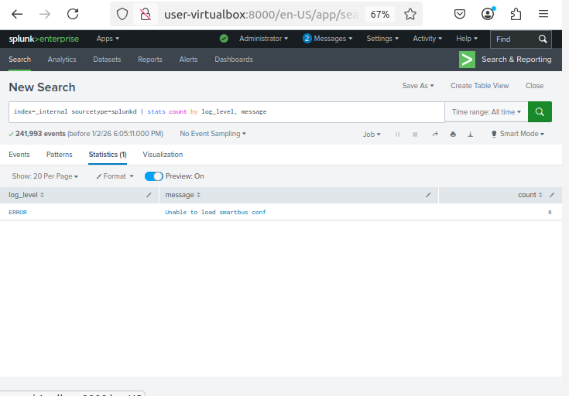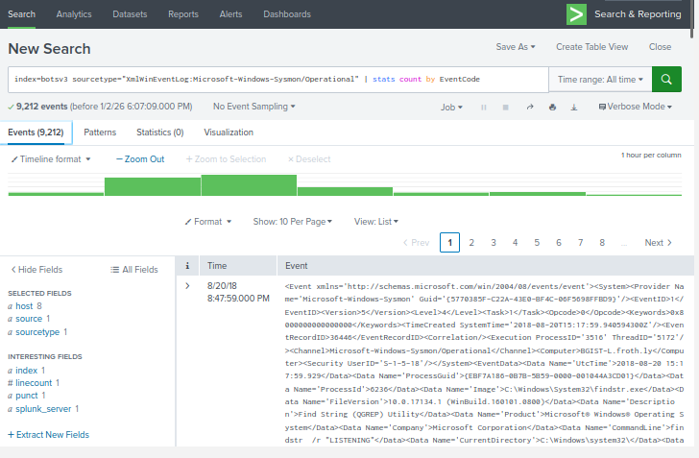

Conclusion
This study was able to effectively show how to perform a consistent SOC-like incident analysis with the BOTSv3 dataset and Splunk. The results indicate a multi-stage attack that consists of the use of malicious email delivery, malware execution with the use of macros, privilege escalation, account persistence, and network reconnaissance.
Comparing the logs of various sources of data, the investigation has identified the significance of centralised logging, real-time monitoring, and competent analysis in identifying and reacting to cyber threats. The procedures employed in this investigation are remarkably aligned to the actual SOC activities and substantiate the importance of useful security analytics in present organisations.

Reference list
Awan, M.D. (2025). SOC Structure (Tier 1, Tier 2, Tier 3 Analysts). [online] Linkedin.com. Available at: https://www.linkedin.com/pulse/soc-structure-tier-1-2-3-analysts-muhammad-dilshad-i9nef.
Granadillo, G.G., Zarzosa, S.G. and Diaz, R. (2021). Security Information and Event Management (SIEM): Analysis, Trends, and Usage in Critical Infrastructures. Sensors, [online] 21(14), p.4759. doi:https://doi.org/10.3390/s21144759.
IBM (2021). Security Operations Center. [online] Ibm.com. Available at: https://www.ibm.com/think/topics/security-operations-center.
Jangampeta, S., Mallreddy, S.R. and Reddy, J. (2021). Anomaly Detection for Data Security in SIEM: Identifying Malicious Activity in Security Logs and User Sessions. International Journal For Innovative Engineering and Management Research, [online] 10(12), pp.295–298. doi:https://doi.org/10.48047/IJIEMR/V10/ISSUE12/39.
Kidd, C. (2023). SOCs: Security Operation Centers Explained. [online] Splunk-Blogs. Available at: https://www.splunk.com/en_us/blog/learn/soc-security-operation-center.html.
Paul, D. (2025). TryHackMe Incident Handling with Splunk — Write-Up. [online] Medium. Available at: https://medium.com/@Paulinhx/tryhackme-incident-handling-with-splunk-write-up-4821b89d1eed [Accessed 2 Jan. 2026].
Sapegin, A., Jaeger, D., Amir Azodi, Gawron, M. and Meinel, C. (2014). Normalisation of Log Messages for Intrusion Detection. [online] 9(3), pp.167–176. Available at: https://www.researchgate.net/publication/265646792_Normalisation_of_Log_Messages_for_Intrusion_Detection.
Shelke, P. and Frantti, T. (2025). Exploring the Possibilities of Splunk Enterprise Security in Advanced Cyber Threat Detection. International Conference on Cyber Warfare and Security, [online] 20(1), pp.605–613. doi:https://doi.org/10.34190/iccws.20.1.3326.

